1. 
2. Command🡺 CTRL + SHIFT + A  
   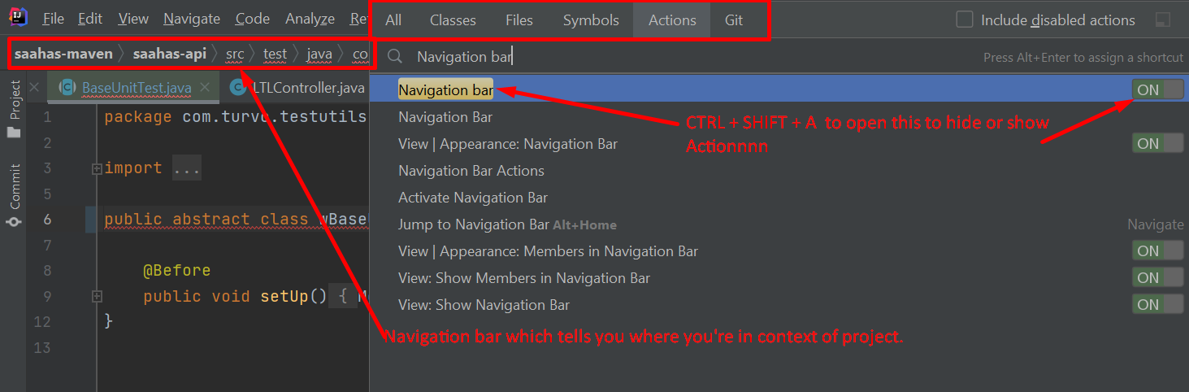
3. Command to open navigation bar in loosely way: ATL + HOME  
     
   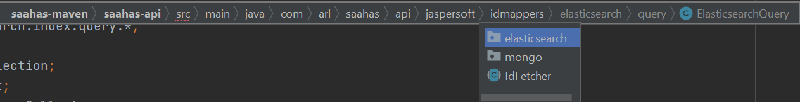
4. 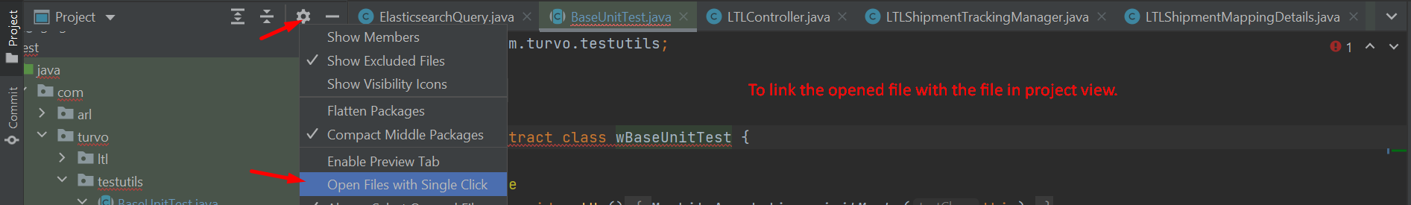
5. 